Date:

This letter is to acknowledge receipt of the following IN KIND donation made to_____________________________________, a program of CharitySmith.

___________________________ is the primary Fund Administrator for the _________________________________ which is a program of CharitySmtih.

CharitySmith
National Society of Memorial Funds (EIN# 87-0636433).
Mailing address: 13100 Filly Lane
Truckee, CA 96161.

The value of your gift in the amount of ____________ is tax deductible. Thank you again for your donation.

Sincerely,

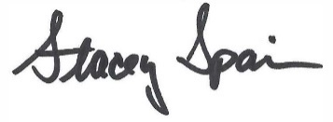

Stacey Spain
Executive Director
CharitySmith

